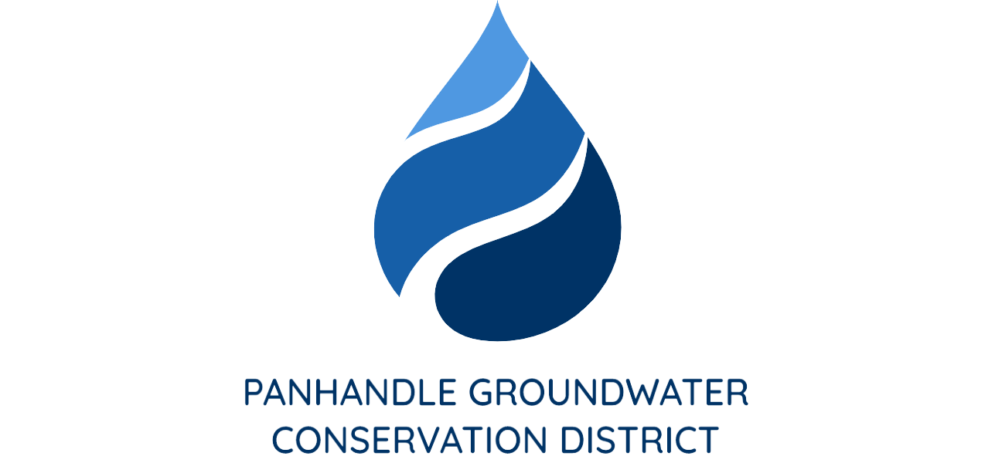

PRESS RELEASE
Contact: Britney Britten, General Manager
Panhandle Groundwater Conservation District
(806) 883-2501
britney@pgcd.us

FOR IMMEDIATE RELEASE

Texas Well Owner Network to Host Water Well Screening Event

WHITE DEER, TX. (October 25, 2022) – Texas Well Owner Network (TWON) is hosting an educational meeting on Wednesday, November 16 from 10:00 a.m. to 2:00 p.m. in the Sand Sage Room at the Hemphill County Exhibition Center, 10965 Exhibition Center Rd, Canadian, TX 79014. In addition to the educational training, landowners will have the opportunity to get their wells tested for a small fee.
TWON is an educational training for Texas residents who depend on household wells for their water needs. TWON is for private well owners who want to become familiar with groundwater resources, septic system maintenance, well maintenance, water quality and water treatment. This training is free to anyone who wants to participate.
Well owners may pick up sample containers with instructions at any of the following locations: Hemphill County UWCD, 211 N. 2nd St in Canadian; Hemphill County AgriLife Extension office, 10956 Exhibition Center Rd. in Canadian; Roberts County AgriLife Extension office, 112 Waters Street in Miami, or Wheeler County AgriLife Extension office, 7939 U.S. Highway 83 in Wheeler. Well owners may bring their water samples the day prior to the event (Tuesday, November 15) to be screened for nitrate-nitrogen, total dissolved solids (TDS), arsenic and E. coli bacteria, to any location mentioned above and between the times of 8:30 a.m. and 10:00 a.m. The cost per sample is $15.00.
“The District is thankful to participate in such an important event.” Said General Manager, Britney Britten. “We hope this is a great opportunity for our constituents to have their domestic water wells screened.”

Please call Aspen Edgar with any questions at 806-883-2501, or email, aedgar@pgcd.us

